2)
import java.util.*;
class Pavan{
public static void main(String[] args){
Scanner sc=new Scanner(System.in);
System.out.println("E.pavan kunar reddy\n51834760");
System.out.println("enter size of array");
int n=sc.nextInt();
int arr[]=new int[n];
int a[]=new int[n];
int b[]=new int[n];
int k=0;
int l=0;
System.out.println("enter all elements");
for(int i=0;i<n;i++){
arr[i]=sc.nextInt();
}
for(int i=0;i<n;i++){
if(arr[i]%2==0)
{
a[k]=arr[i];
k++;
}
else{
b[l]=arr[i];
l++;
}

}

System.out.print("even: ");
for(int i=0;i<k;i++){
System.out.print(a[i]+" ");
}
System.out.println();
System.out.print("odd: ");
for(int i=0;i<l;i++){
System.out.print(b[i]+" ");
}

}
}
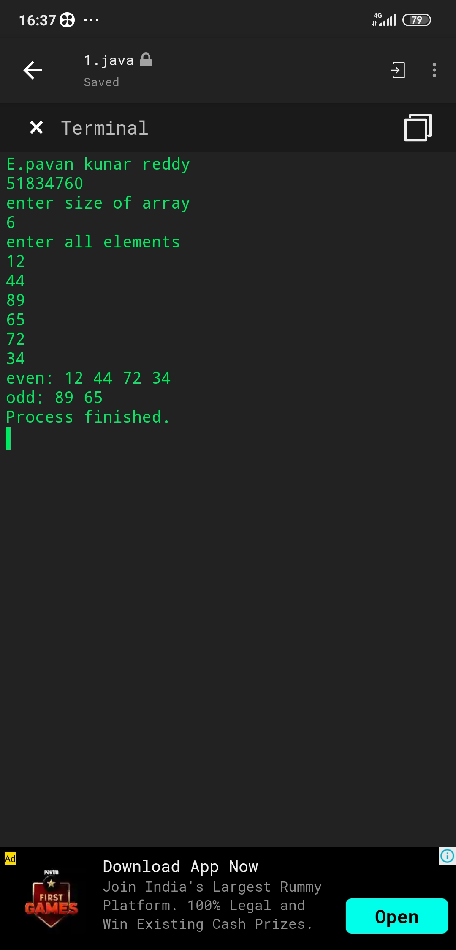

3)
import java.util.*;
interface House{
abstract public void area();
abstract public void windows();
abstract public void stairs();
}
class Your_house_name implements House{
public void area(){
System.out.println("1000 sq.ft");
}
public void windows(){
System.out.println(" 4 windows");
}
public void stairs(){
System.out.println("3 stairs");
}

public static void main(String[] args){
Your_house_name o=new Your_house_name();
System.out.println("E.pavan kumar reddy\n51834760");

o.area();
o.windows();
o.stairs();
}

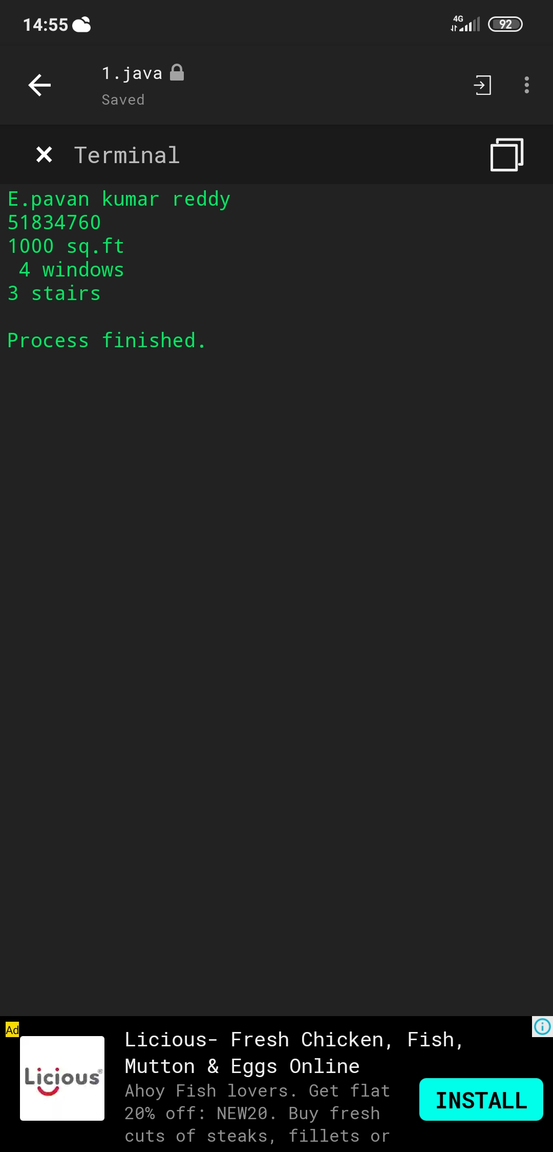

4)
import java.util.*;
class Pavan{
public static void main(String args[]){
System.out.println("E.pavan kumar reddy\n51834760");
int n=1;
for(int i=1;i<7;i++){
for(int j=1;j<i;j++){
System.out.print(n);
n++;
}
System.out.println();

}
}
}
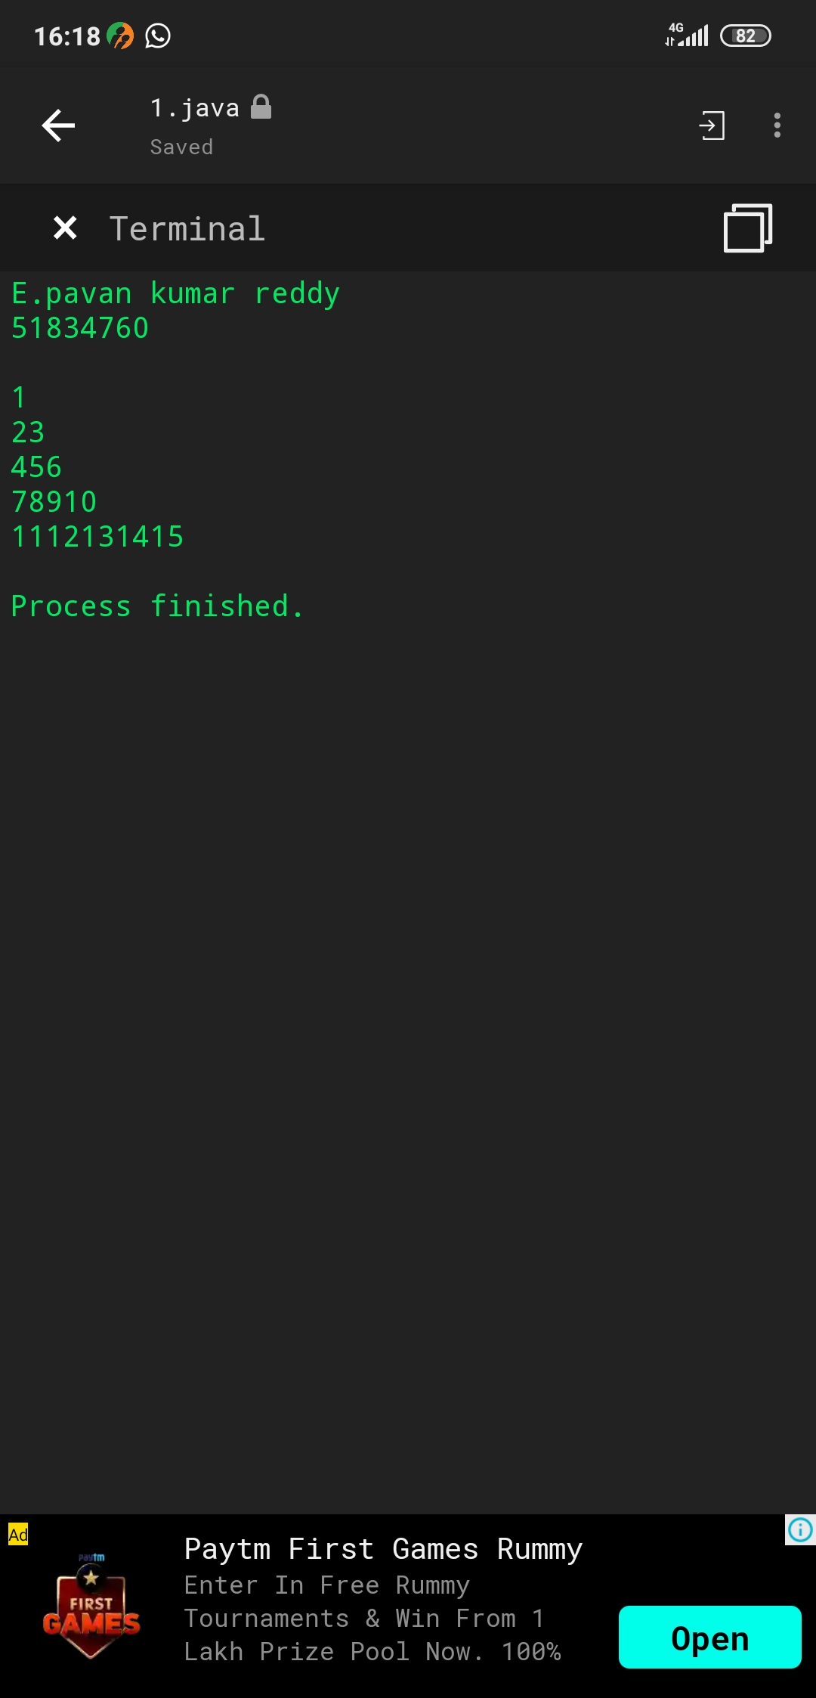

5)
import java.util.*;
class Pavan{
public static void main(String args[]){
String str[]=args;
int count=0;
String temp="";

for (int i = 0; i < count; i++)
{
for (int j = i + 1; j < count; j++) {
if (str[i].compareTo(str[j])>0)
{
temp = str[i];
str[i] = str[j];
str[j] = temp;
}
}
}

//Displaying the strings after sorting them based on alphabetical order
System.out.print("Strings in Sorted Order:");
for (int i = 0; i <= count - 1; i++)
{
System.out.print(str[i] + ", ");
}

}
}

